### **Create a Custom CloudWatch Dashboard**

To create a CloudWatch dashboard, go to the *Services* dashboard. Under the *Management & Governance* section, select **CloudWatch**. Here, select **Dashboards**, then **Create dashboard**.

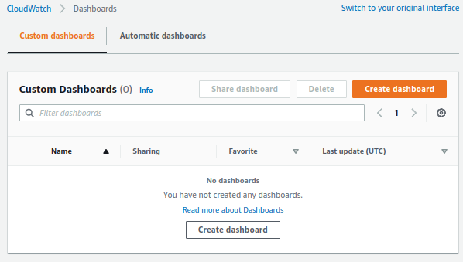

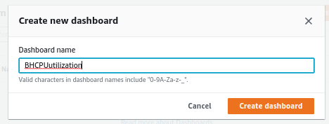

Name this dashboard *BHCPUutilization*. Once you've added in the name, select **Create Dashboard**. You will then be prompted to add a widget. We want to add a *Line* widget. Click **Next**. Select **Metrics**, then select **Configure**.

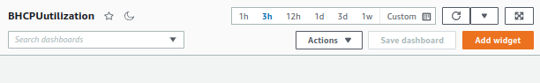

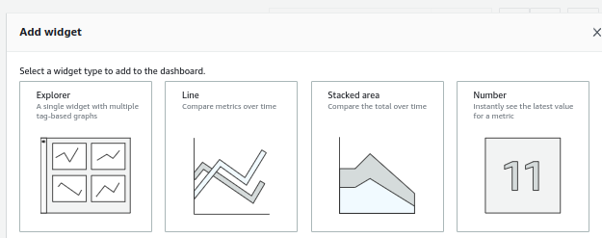

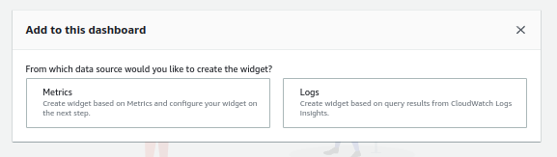

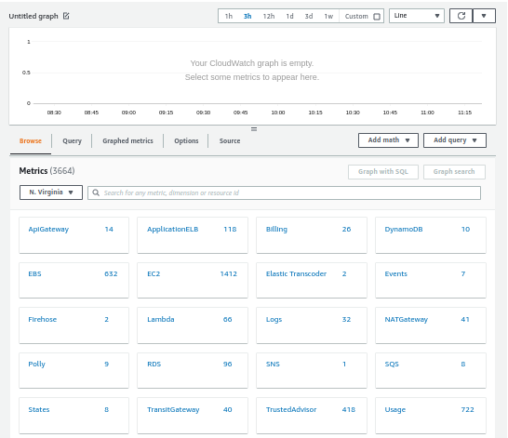

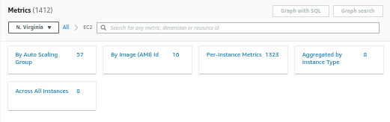

Now, we need to add a metric for the dashboard. To do that, select **EC2**, then select **Per-InstanceMetric**. Here, search for *CPUUtilization*, and then select **bastion-host**. At the top of the page, select the **custom** dropdown, and set the time interval to **15** in the *minutes* section. After you've set the time, click **Create Widget**, and then click **Save dashboard**.

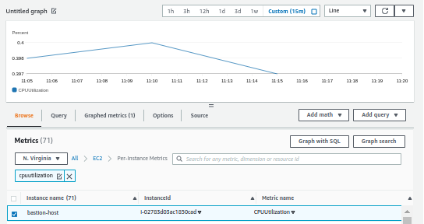

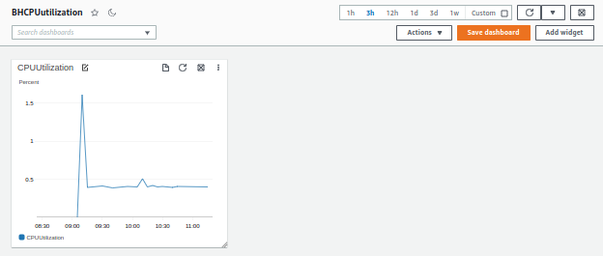

### **Create the Second Custom Dashboard**

Now, we need to make our second dashboard. Once again, in the CloudWatch console, select **Dashboards**. Select **Create dashboard**, and name it *APPCPUutilization*. Now, click **Create Dashboard**. This time, select the **Stacked area** widget. Click **Next**.

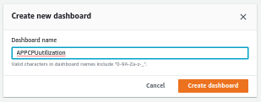

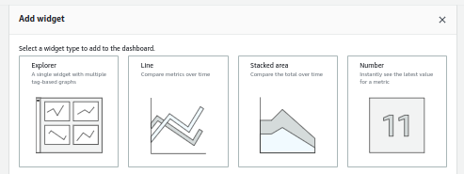

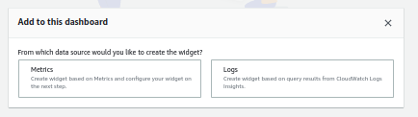

Select **Metrics**. Then, click **Configure**. Again, add the metric for *EC2*, and select *Per-InstanceMetric*. Search for *CPUUtilization*. Select the following instances:

* database
* instance-wordpress
* instance-wordpress

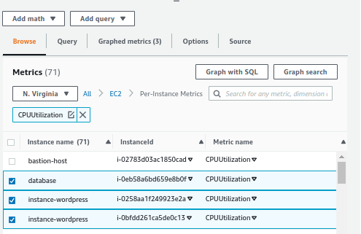

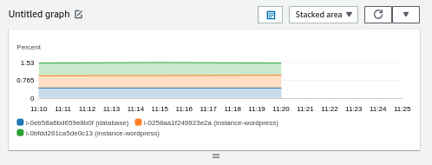

With those selected, set the custom time interval to **15** minutes once again. Now select **Create Widget**, and then **Save dashboard**.

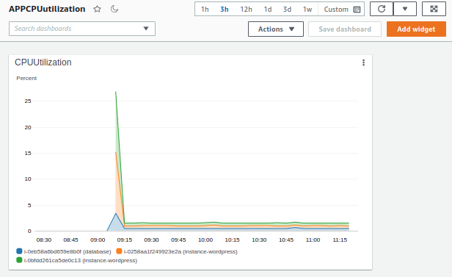

### **Add Additional Widgets to the Custom Dashboard**

Now that we've created our two dashboards, and provided them both with widgets, we need to create a widget for an already-created dashboard. To do this, on the desired dashboard (for now, let's use the one we just made), select **Add widget** from the top of the page. This time, let's select the **Number** widget. For the metric, select **ApplicationELB**, then **Per AppELB Metrics**, and select the metrics named **RequestCount**. Finally, select **Create Widget**, and then **Save Dashboard**.

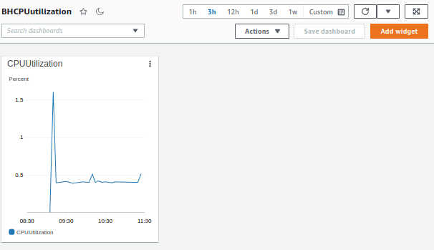

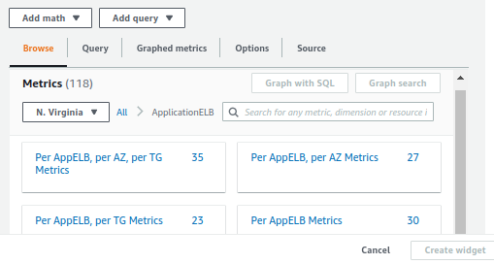

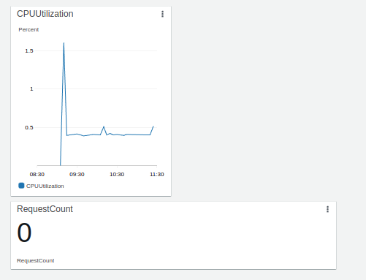

Now we need one more widget. Again, select **Add Widget**, and then this time select **Line**. Click **Next**. Select **Metrics**, and click **Configure**. For the metrics, select **EC2**, **Per-Instance Metrics**, search for *NetworkIn*, and then select the two *wordpress* EC2 instances and our *database* instance. With those selected, set the custom time interval to **15** minutes once again. Now select **Create Widget**, and then **Save dashboard**.

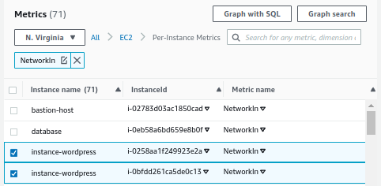

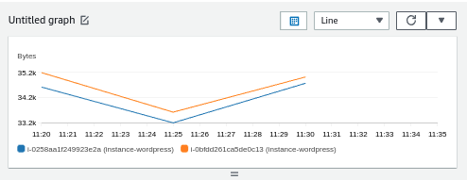

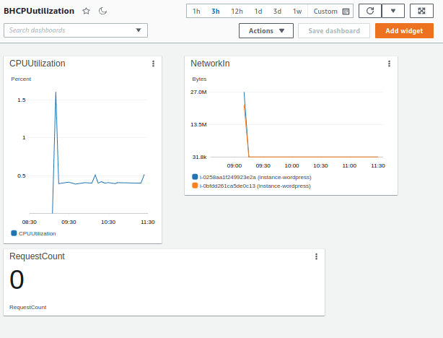

## **Generate Traffic**

With our dashboards created, we now want to generate some traffic for these dashboards. To do so, go to the *EC2 Dashboard* and then, under *Load Balancing*, select **Load Balancers**.

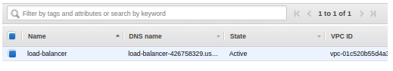

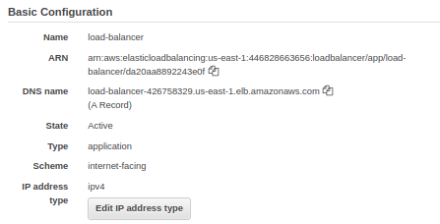

Copy the *DNS Name* and then paste it into a new tab of our preferred web browser. We are taken to our WordPress site. Select your desired language and then **Continue**. Fill in the information as:

* *Site Title*: Labdemo
* *Username*: LAuser
* *Password*: (Whatever you want)
* *Your Email*: The email you wish to use for this lab

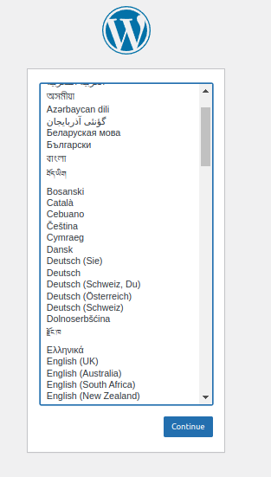

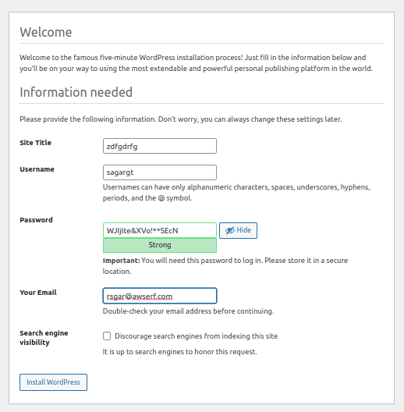

Now, select **Install Wordpress**. Using the username and password, log into WordPress.

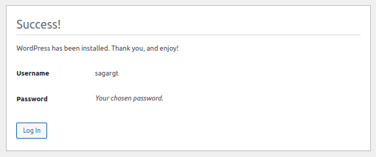

Go back to the CloudWatch dashboard. Under *Management & Governance* select **CloudWatch**. On the next page, select **Dashboards**. Select the first dashboard. Here, we should see information has started to populate our widgets, which tells us that we have set up everything correctly.

